|  |  |  |  |  |  |  |
| --- | --- | --- | --- | --- | --- | --- |
|  |  |  |  |  |  |  |
|  |  | **Design Work** |  |  |  |  |
|  | **Sl** | **Page Name** | **Html Page** | **Responsive** | **Total** |  |
|  | 1 | SEASON STATS (SINGLE) | 5 | 6 | 11 |  |
|  | 2 | SEASON STATS (GROUP) | 5 | 6 | 11 |  |
|  | 3 | BOX SCORE (SINGLE) | 5 | 6 | 11 |  |
|  | 4 | BOX SCORE (GROUP) | 5 | 6 | 11 |  |
|  |  |  |  |  |  |  |
|  |  | Total Hour | 20 | 24 | 44 |  |
|  |  |  |  |  |  |  |
|  |  | **Development Work** |  |  |  |  |
|  | **Sl** | **Page Name** | **Hours** |  |  |  |
|  | 1 | SEASON STATS (SINGLE) | 3 |  |  |  |
|  | 2 | SEASON STATS (GROUP) | 5 |  |  |  |
|  | 3 | BOX SCORE (SINGLE) | 3 |  |  |  |
|  | 4 | BOX SCORE (GROUP) | 5 |  |  |  |
|  |  |  |  |  |  |  |
|  |  | Total Hour | 16 |  |  |  |
|  |  |  |  |  |  |  |
|  | **Total Base Development and Design Work** | | | | **60 Hours** |  |
|  |  |  |  |  |  |  |

**Base Design and Development Work**

**Work Time of States and Box Score Page**

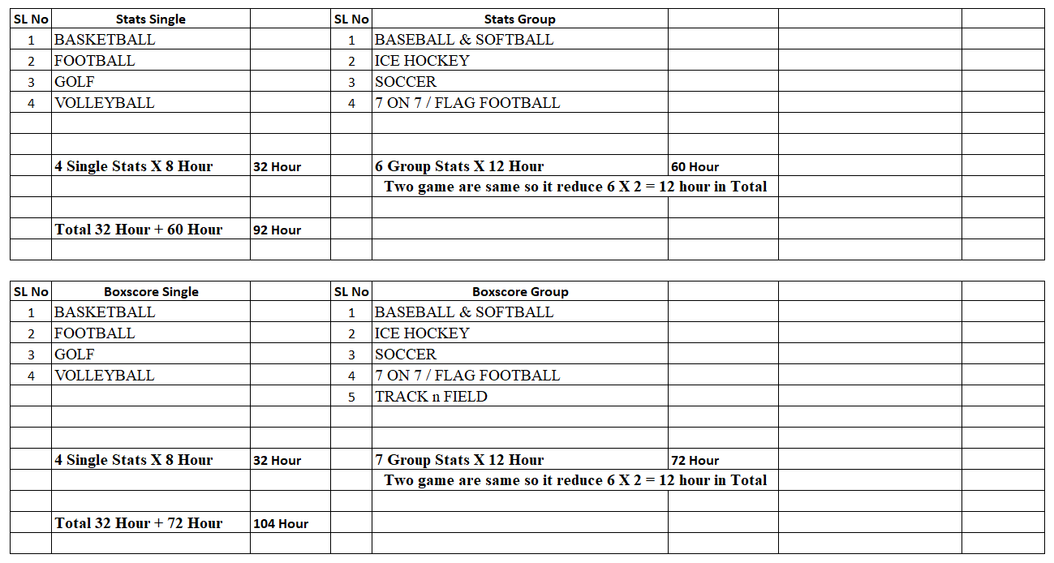

**Clarification Of Each Games Time Calculation**

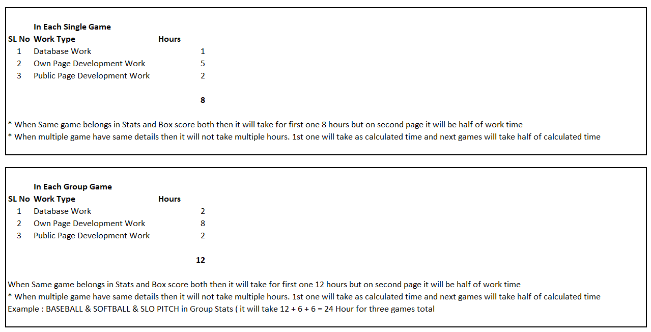

**Total Work Time of States and Box Score**

